Pagination and Filtering
Check module GenericRecordListView, it’s an extension that we need to activate.
It’s SC, so we can not use since it’s SCA module, we need to create a new version SC compliant.
So, we discard pagination since it becomes complicated and consumes lot of hours.

Filtering
Added keyword select on template:
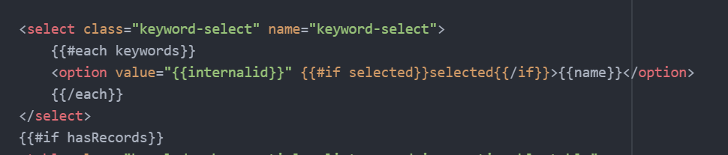
Then, since it’s pageTypeBaseView we can add a call to getEvents, and then the function to call whenever selected a keyword:
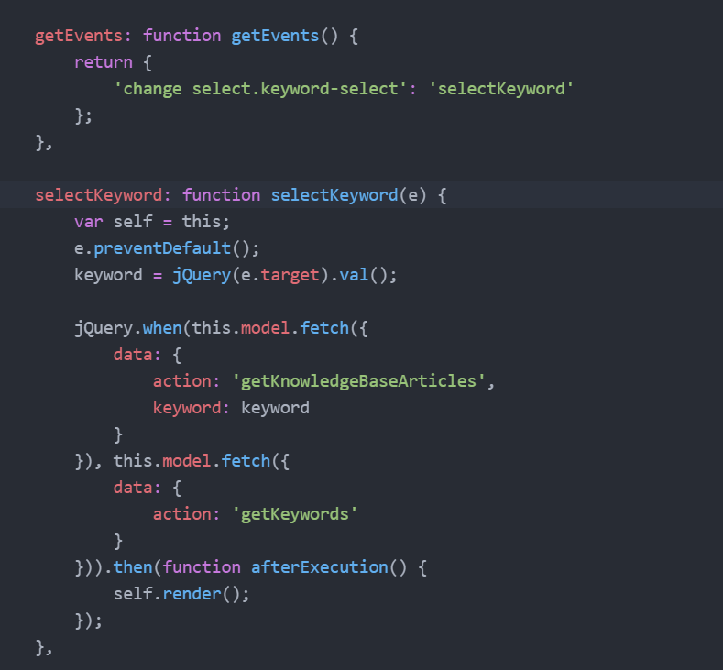
On this function I will obtain the knowledge base articles that I need.

Then on getContext, I will give back these results, and also set the keyword I selected as selected since it does a refresh and I lost the reference to this keyword selected:
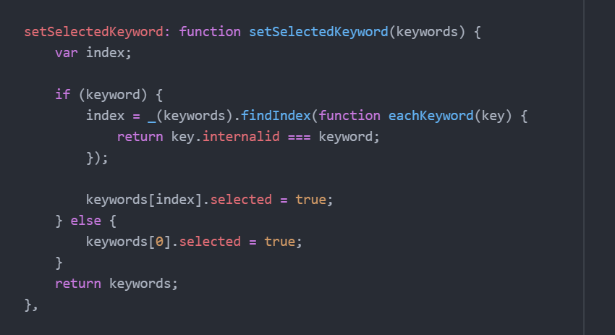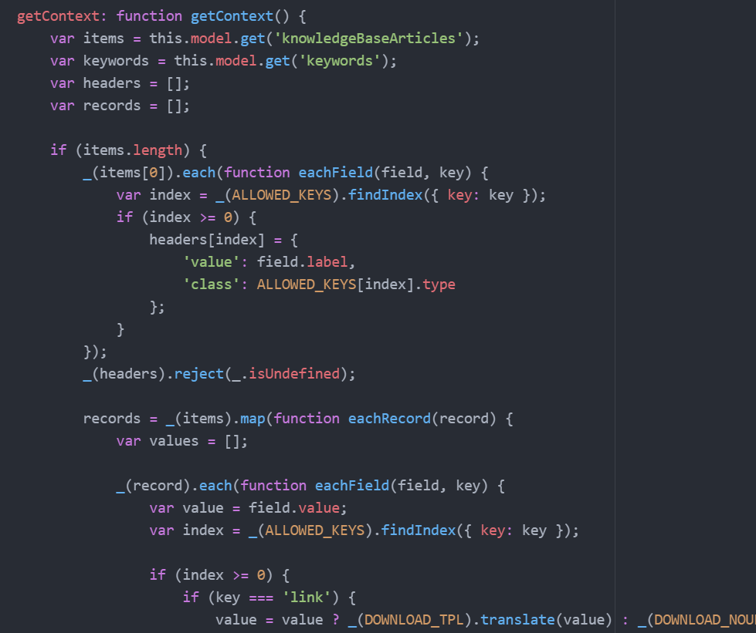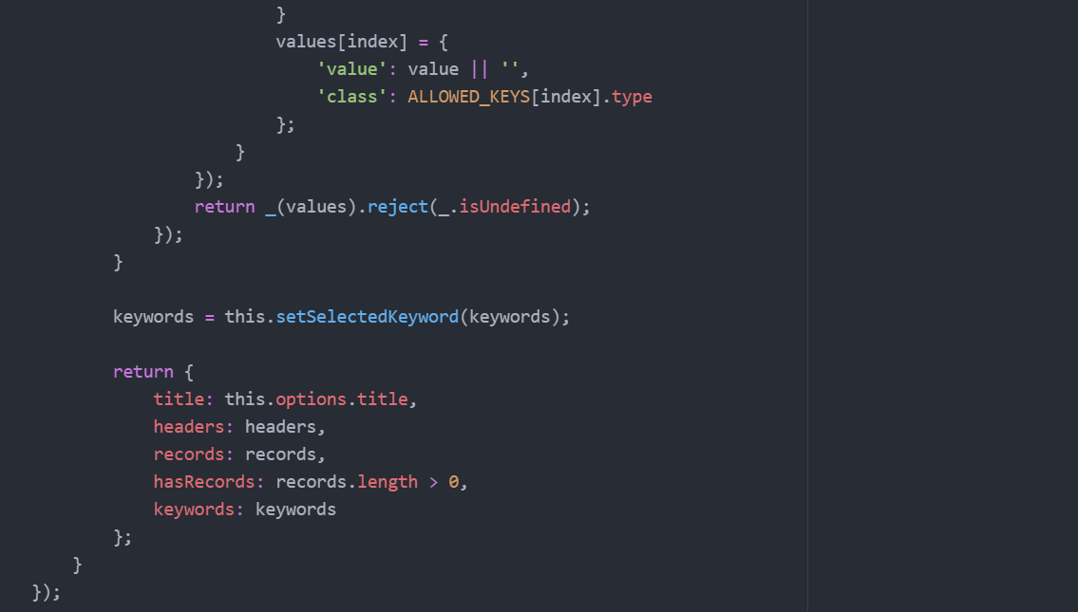

Use jquery when to call 2 things at the same time.
Use JEM form, get events, etc.
Usar native selector.

